Service Article:
Topic: “Year of Efficiency,” Can We Expect More Tech Layoffs?
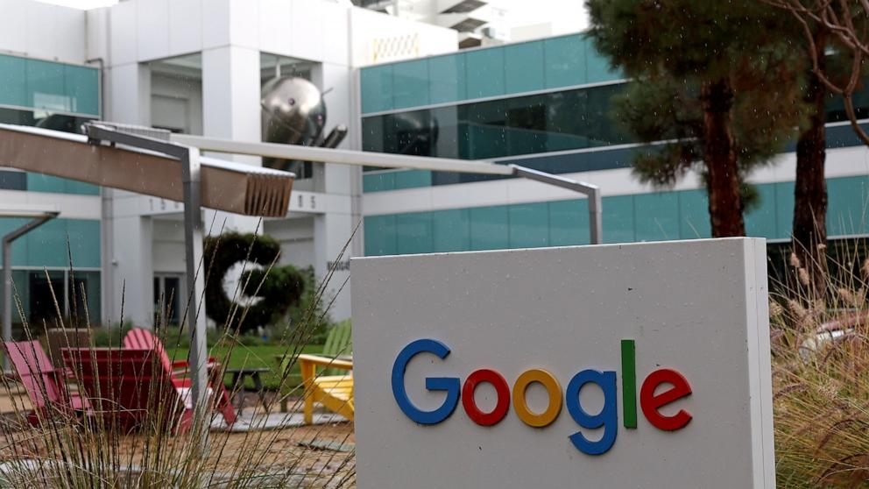
2023 was coined the “Year of Efficiency” in Big Tech with many companies cutting jobs. This trend seems like it will continue into 2024 as tech companies shift their focus and investments into industries such as generative artificial intelligence. Analysts believe that layoffs this year could be smaller compared to the amount in 2023 and more targeted. This could be due to tech companies wanting to catch up in the AI race and need to look where they can cut costs in order to support the increased spending for the new technology.
Alphabet- the parent company of Google- suggested that it will invest in its “biggest priorities” while Google had laid off thousands of employees across numerous divisions which include those working in the voice assistant unit, employees who worked for Pixel and Fitbit, and even cuts to those working in its advertising department (Soni and Mehta, 2024). Similarly, Amazon has been making their own cuts, most notably the corporation laid off hundreds of employees in the streaming and studio operations department, live-streaming, and audible audiobook units. There have already been more than 7,500 tech employees who have been laid off in January, 2024.
According to analysts D.A. Davidson and Gil Luria, it is evident that tech companies don’t want to “get left behind in the AI revolution” and they have been prioritizing increasing their technological capabilities (Soni and Mehta, 2024). This usually comes at the expense of other company initiatives. Google has been trying to make advancements in its AI technology to compete with Microsoft and it has recently unveiled its model called “Gemini”. Another company developing their own AI models is Amazon, which is working on a model named “Olympus” in hopes that it could rival OpenAI’s popular ChatGPT model.
Even though there have been thousands of job cuts in the tech industry, this has led to companies changing what roles they are looking to hire for in 2024. Positions in AI are becoming more in-demand and companies are willing to pay the price for the people who will fill those roles. There is mounting pressure on companies from investors to see returns on investment from generative AI. However, analysts believe it will still take a few years for the technologies to be profitable.
Source:
Soni, A., & Mehta, C. (2024, January 16). Tech layoffs continue after “year of efficiency” | Reuters. Reuters. https://www.reuters.com/technology/tech-layoffs-continue-after-year-efficiency-2024-01-16/

